Journal Entire Steps
3 Series Account: 3020044 must be in Debit:
5 Series Account: 5000104 must be in Credit:
Note:
3 Series is always Debit
5 series is always Credit
Sample
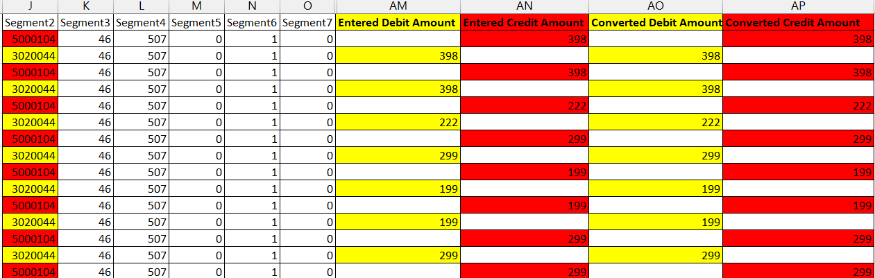
Sample Entry
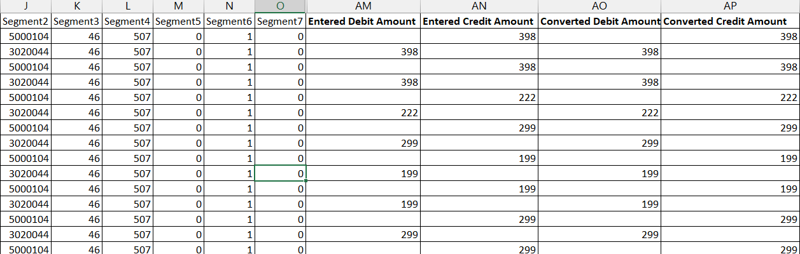
Note: The column can be changed, but the credit debit must be matchin both column

Verification Steps
Sum of the Debit must match the Credit
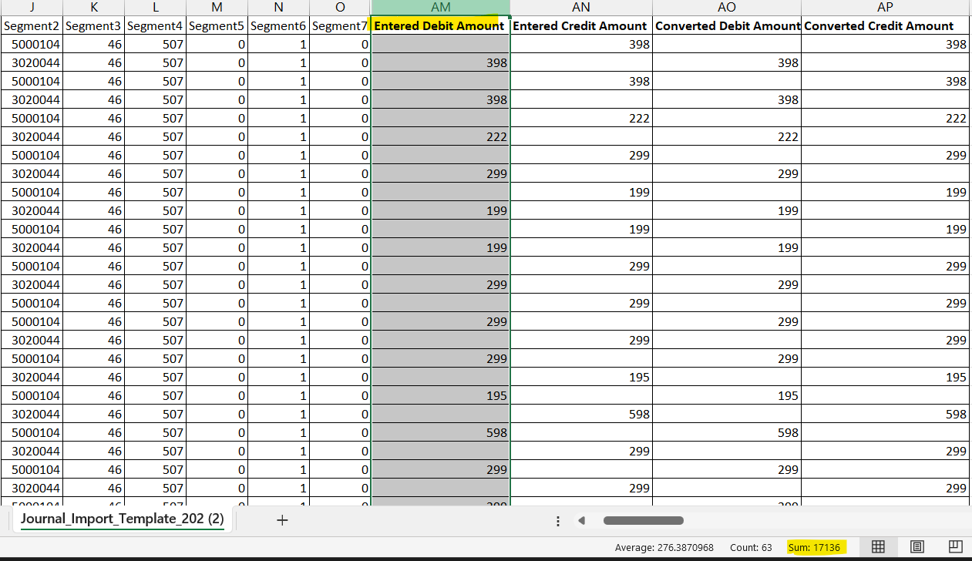
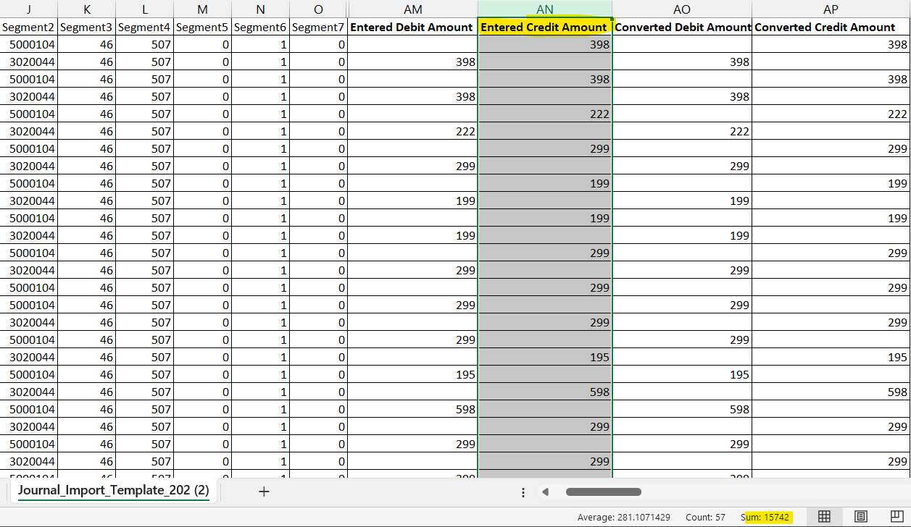
The above case the sum of the debit is not matched with the credit, the journals will be in unbalanced and the system will throw an error
Note: the same applies to the converted debit amount column and converted credit amount columns
The converted debit amount column should match the converted credit amount columns
Issue caused
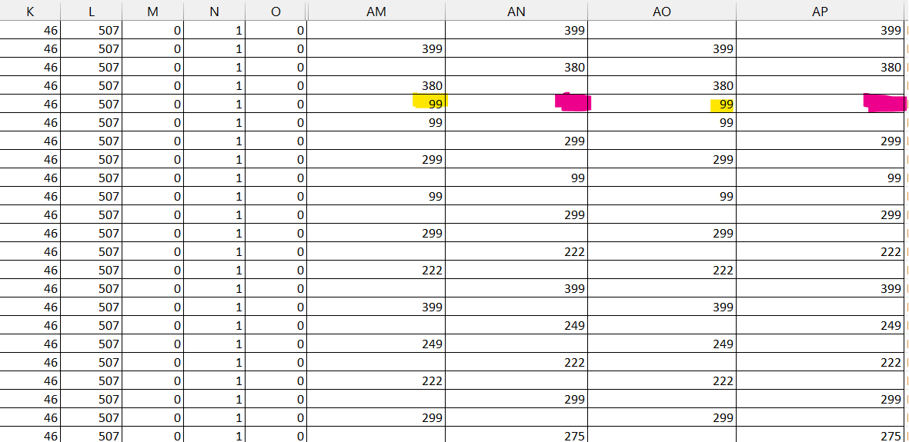
The Yellow highlighted 99 is placed in wrong column, it must be placed the in the Pink column (Credit column)
If the sum is not matched, either the amount is wrongly entered or entered in wrong column

After Correction Verification
The Debit amount will match the Credit amount as mentioned below
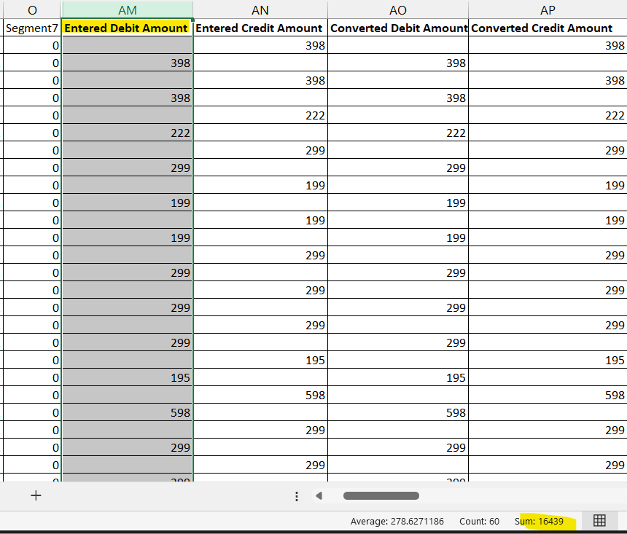
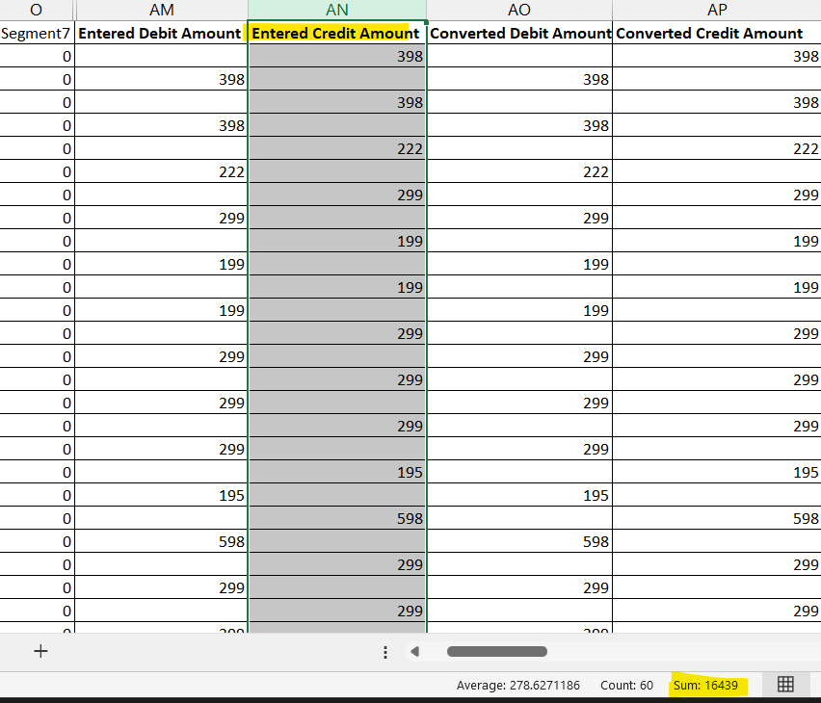
Note: The Converted Debit Amount and Converted Credit Amount should also match as per the Entered Debit Amount and Entered Credit Amount

